dwdc esfsdrfgrgrrrrrrhjbjblOMoARcPSD|1714095



SRS: Airline Management system

Table of contents

|  |  |
| --- | --- |
| 1. Introduction | 3 |
| 1.1 Purpose | 3 |
| 1.2 Scope | 3 |
| 1.3 Glossary | 3 |
| 1.4 Overview | 3 |
| 2. Overall Description | 4 |
| 2.1 Problem Statement | 4 |
| 2.2 Existing System | 4 |
| 2.3 Proposed System | 4 |
| 2.4 Product Functions | 5 |
| 2.5 User’s characteristics | 6 |
| 2.5.1 User’s Requirements | 6 |
| 2.5.2 User’s Education Level | 6 |
| 2.5.3 User’s Technical Expertise | 6 |
| 2.6 Constraints | 6 |
| 2.7 Assumption and Dependencies | 6 |
| 3. Requirement Specification | 7 |
| 3.1 Functional Requirement | 7 |
| 3.1.1 Performance Requirement | 7 |
| 3.1.2 Design Constraints | 7 |
| 3.1.3 Hardware Requirement | 8 |
| 3.1.4 Software Requirement | 8 |
| 3.1.5 Other Requirement | 8 |
| 3.2 Non-Functional Requirement | 9 |
| 4. Diagrams | 10 |
| 4.1 Use Case Diagram | 10 |
| 4.2 Class Diagram | 11 |
| 4.3 State Diagram | 12 |
| 4.4 Data Flow Diagrams | 13 |
| 4.4.1 Level 0 | 13 |
| 4.4.2 Level 1 | 13 |
| 4.4.3 Level 2 | 14 |

2

# Introduction

## Purpose

Airline Reservation System aims to automate the flight operations and ticketing / seat booking and confirmation system of an Airline company. The software is providing options for viewing different flights available within a different timing for a specific day. That provide customers within facility to able to book ticket smoothly. The customers can modify and able to cancel the ticket for any reason. That prepare within a role and policies. The software should provide option for checking availability of the tickets. That is important for the customers to get message if the ticket unavailable. That will be displayed into customers. The customers should be noted when the change has been made or any further changes.

## Scope

The airline booking website is an application stored in the user server. The purpose of the website is to resolve the client to allow website users to perform tasks related to booking an airline flight. The system enables to perform the following functions:

Automation of flight operations Automation of ticketing / seat booking confirmation system

Cancellation

Improved and optimized service

## Glossary

ARS-Airline Reservation System LAN-Local Area Network

GUI-Graphical User Interface OS-Operating System

RAM-Random Access Memory MB-Mega Bytes

GB-Giga Bytes

Mbps-Megabits per second HDD-Hard Disk Drive 1

UML-unified modeling language

* 1. **Overview**

The remaining section of this document provide a general description including characteristic of the users of this product, the product’s hardware, and functional and non-functional requirements of the product.

## Overall Description

* 1. **Problem Statement**

Developing an AIRLINE RESERVATION SYSTEM- ARS for an airline company that want to automate its flight operations and ticketing / seat booking and confirmation system.

## Existing System

Before the automation the system suffered from following DRAWBACKS:

Existing system is highly manual and involves a lot of paper work and calculation and therefore may be prone to errors. This lead to inconsistency and inaccuracy.

The data may be lost, stolen or destroyed because it is stored on paper.

The existing system consumes a lot of time causing inconveniencing to customers and the staff. Its difficult to update, delete, or view the data due its manual nature.

Increasing number of passengers leads to difficulty in maintaining and retrieving details.

## Proposed System

The ARS is proposed with the following,

The computerization of the reservation system will reduce a lot of paperwork and hence load on the hence the load on airline admin and staff.

The machine will perform all calculations. Hence chances of error are nearer to nil.

The passenger, reservation, cancellation list can be easily retrieved and any required addition, deletion, updation can be performed easily and fast.

Proper way of confirmation of bookings etc.

4

## Product Functions

Booking agents with varying levels of familiarity with computers will mostly use this system. With this on mind, an important feature of this software is that it will be relatively simple to use. The scope of this product encompasses:

**SEARCH:** This function allows the booking agent to search for airplane’s and ticket’s availability between two cities, i.e. departure city and arrival city, the date of departure, preferred time and number of passengers.

**SELECTION:** This function allows a particular airplane to be selected from the displayed list. All details such as;

Airplane number

Date, time and place of departure Date, time and place of arrival Fare per head etc.

**Review:** If seats are available, then system prompt’s for the booking. All the information including total fare with taxes and flight details are reviewed.

**Traveler Information:** The details of all passengers supposed to travel including name, address, contact number, email etc.

**Payment:** It asks the agent to enter the various credit card details of the person making reservation i.e.

Credit card type Credit card number

Expiration date of the card The name on card etc.

**Cancellation:** The system allows the passenger to cancel a reservation and register the information regarding his/her ticket. It includes Confirmation no, name, date of journey, fare deducted.

## User Characteristics

* + 1. **User requirements**

User properties like Name, Address, Age,

Associated with Flight Miles accumulated and Credit Card information.

Flight properties like Departing/Arriving City, Departure/Arrival dates and times, Miles, and an identifying Flight Number.

Flight Seat properties of identifying seat number, reserved and flight

* + - * Associated to Flight by flight number

## User Education Level

At least user of the system should be comfortable with English Language.

## User’s Technical Expertise

User should be comfortable using general purpose applications on the computer system.

## Constraints

System constraints:

The system is a web base, so it will run on a web browser i.e. IE, Chrome, Firefox etc. The system will run under any OS with internet functionality.

## Assumption and Dependencies

Booking agent will be having a valid user name and password to access the system. The software needs booking agent to have complete knowledge of ARS.

Software is dependent on access to internet.

6

## Requirement Specification

This section highlights the functional requirements, non-functional requirements and other requirements.

## Functional Requirements

* + 1. **Performance requirements**

**User Satisfaction:** The system is such that it stands up to the user expectations.

**Response Time:** The response of all operations is good.

**Error Handling:** Response to user errors and undesired situation has been taken care of to ensure that the system operates without halting.

**Safety and Robustness:** The system is able to avoid or tackle disastrous action. In other words it should be foul proof.

**Portable:** The software should not be architecture specific. It should be easily transferable to other platforms if needed.

**User Friendliness:** The system is easy to learn and understand. A native user can also use the system effectively, without any difficulties.

## Design constrain

There are a number of factors in the client’s environment that may restrict the choices of a designer. Such factors include standards that must be followed, resource limits, operating environment, reliability and security requirements and policies that may have an impact on the design of the system.

* + - * **Standard Compliances** This specifies the requirement for standards the system must follow. The standards may include the report format and accounting properties.
      * **Hardware Limitations** Hardware limitations can include the types of machine to be used, operating system available on the system, languages support and limits on primary and secondary storage.
      * **Reliability and Fault Tolerance** Fault tolerance requirement can be place a constraint on how the system is to be designed. Recovery requirements are often on

integral part here, detailing what the system should do if some failure occurs to ensure certain properties. Reliability requirements are very important for critical application.

**Security** requirements are particularly significant in defense system and database system. They place restrictions on the use of certain commands, control access to data, provide different kinds of access requirements for different people, require the use of passwords and cryptography techniques and maintain a log of activities in the system.

## Hardware Requirements

For the hardware requirements like memory restrictions, cache size, the processor, RAM size etc... those are required for the software to run.

## MINIMUM Hardware Requirements

Processor Pentium IV Hard Disk Drive 100 GB RAM 1 Gb

## PREFERED HARDWARE REQUIREMENTS

Processor Core i3 Hard Disk Drive 500 GB RAM 4 GB

## Software Requirements

Any window-based operating system with DOS support are primary requirements for software development. Windows7 and up are required. The system must be connected via LAN and connection to internet is mandatory.

## Other Requirement

Security Portability Correctness Efficiency Flexibility Testability Reusability

8

## Non-Functional Requirements

* + 1. **Security**

The system is must automatically log out all customers after a period of inactivity. The system should not leave any cookies on the customer’s computer containing the user’s password. The system’s back-end servers shall only be accessible to authenticated management.

## Reliability

The reliability of the overall project depends on the reliability of the separate components. The main pillar of reliability of the system is the backup of the database which is continuously maintained and updated to reflect the most recent changes. Also the system will be functional under a container. Thus the overall stability of the system depends on the stability of the container and its underlying OS.

## Availability

The system should be available at all the times, meaning the user can access it using a web browser ,only restricted by the downtime of the server on which system runs. A customer friendly system which is in access of people around the worlds should work 24 hours. In case of hardware failure or database corruption, a replacement page will be shown. Alison caseofhardwarefailureordatabasecorruptionbackupsofthedatabaseshouldbe retrieved from the server and saved by the Organizer. Then the service will be restarted. It means 24x7 availability.

* + 1. **Maintainability** Incase of a failure , re-installation of the system will be done
    2. Also, the software design is being done with modularity in mind so that maintainability can be done efficiently.

## Supportability

Thecodeandsupportingmodulesofthesystemwillbewelldocumentedandeasyto understand. Online user documentation and Help system requirements will be provided.

## Diagram

* 1. **Use Case Diagram**

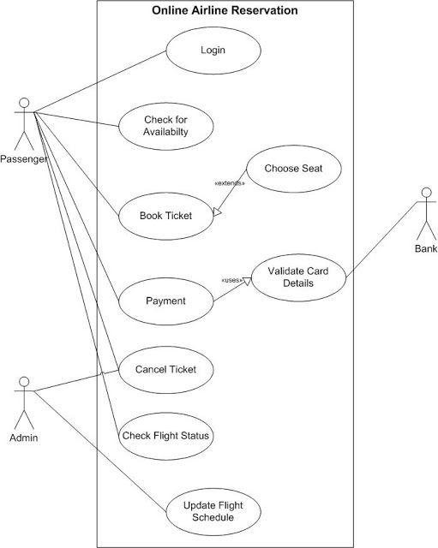

10

## Class Diagram

**Common Functions**

**+searchticket()**

**+bookticket()**

**+cancelticket()**

**+makepayment()**

**+details()**

**Payment**

**+CustomerID: char**

**+cardNo: char**

**+expirayDate: char**

**Customer**

**+CustomerID: Char**

**+name: char**

**+address: char**

**+ph_no: int**

**+age: int**

**+adddetails ()**

**+modifydetails()**

|  |  |
| --- | --- |
| **Bookin** | **g agent** |
| **+id: int**  **+name**  **+passw** | **: char char** |
|  |  |

|  |
| --- |
| **Refund** |
| **+amount: float**  **+CustomerID: char** |
| **+refundAmount()** |

|  |  |
| --- | --- |
| **Booking** |  |
| **+flight_name: char**  **+flight_no: char**  **+destination: char**  **+date_of_journey:date**  **+time: time** |
|  |
|  |

* 1. **State Diagram**

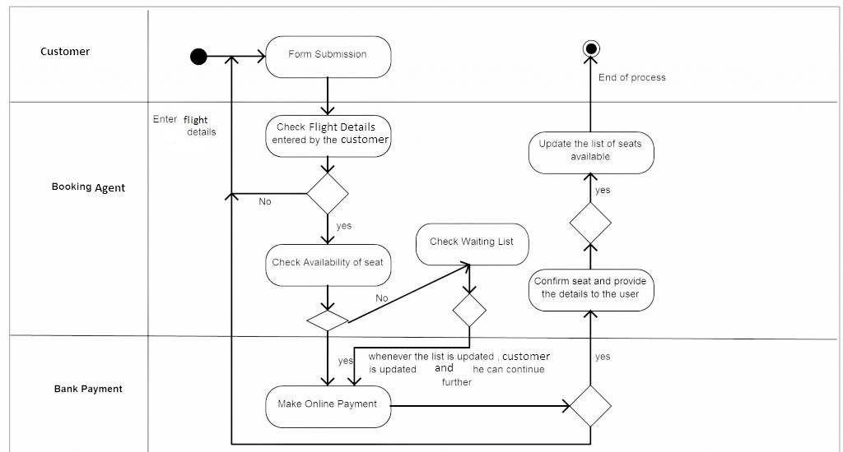

12

## Data Flow Diagram Level 0:

**Airline**

**Reservation**

**Admin**

**User**

**Level 1:**

**Airline Database**

Seat no

Checked status

username, date

Nauseates

Bank details

Payment bill

**Print**

Confirm ticket

Confirm payment

**Payment**

**Check Availability**

**User**

**Level 2:**

# Reservation

Check avail

Apply for ticket conform ticket

Give availability

Conform cancel

# Admin

**User**

Apply for cancel

# Cancellation

Cancel process

view details

# Check Status

Airline Database

payment

details Payment payment process

done

# Payment

14